LAB 1: Dynamic Systems Modeling in MATLAB

Course Number | MENG 3020
Course Title | System Modeling & Simulation
Semester/Year | Semester 3

Lab/Tutorial Report No. | Lab 1
Report Title | Dynamic Systems Modeling in MATLAB
Section No. | 0NA
Group No. | N/A
Submission Date | September 28th, 2025
Due Date | September 21st, 2025

Student Name | Signature* | Total Mark
Michaël McCorkell |  | / 50

* By signing above, you attest that you have contributed to this submission and confirm that all work you have contributed to this submission is your work. Any suspicion of copying or plagiarism in this work will result in an investigation of Academic Misconduct and may result in a ZERO on the work or possibly more severe penalties.
https://academic-regulations.humber.ca/2021-2022/17.0-ACADEMIC-MISCONDUCT

LAB 1: Dynamic Systems Modeling in MATLAB

OBJECTIVES
- To learn how to model the differential equation of motion of mechanical systems in MATLAB
- To compute and analyze the time response of a dynamic system to the step input and ramp input
- To learn how to develop linear models from data

PART A: Modeling and Analysis of Mechanical Systems
Consider the mass-spring-damper system mounted on a massless cart as shown in Figure 1. A damper is a device that provides viscous friction, or damping. It consists of a piston and oil-filled cylinder. Any relative motion between the piston rod and the cylinder is resisted by the oil because the oil must flow around the piston (or through orifices provided in the piston) from one side of the piston to the other. The damper essentially absorbs energy, which is dissipated as heat. The damper does not store any kinetic or potential energy.
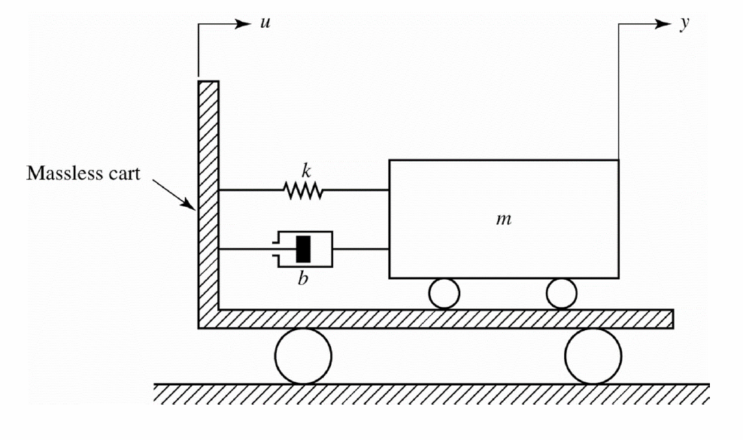
Figure 1: Mass-spring-damper system mounted on a cart.

Let us obtain a mathematical model of this system by assuming that both the cart and the mass-spring-damper system on it are standing still for $t\text{<}0$. In this system,
$u(t)$ is the displacement of the cart and the input to the system,
$y(t)$ is the displacement of the mass relative to the ground is the output of the system,
$m$ denotes the mass,
$b$ denotes the viscous friction (damping) coefficient,
$k$ denotes the spring constant.
We assume that the friction force of the damper is proportional to the relative velocity $\overset{˙}{y}\left(t\right)\text{-}\overset{˙}{u}(t)$ and that the spring is linear; that is, the spring force is proportional to relative displacement $y(t)\text{-}u(t)$.
For translational systems, Newton's second law states that:
$$\sum{F}\text{=}ma$$
where $m$ is a mass, $a$ is the acceleration of the mass, and $\sum{F}$ is the sum of the forces acting on the mass in the direction of the acceleration.

Applying Newton's second law to the present system and noting that the cart is massless, we obtain:
$$m\overset{¨}{y}\left(t\right)\text{=}\text{-}b\left(\overset{˙}{y}\left(t\right)\text{-}\overset{˙}{u}\left(t\right)\right) \text{-}k\left(y\left(t\right)\text{-}u\left(t\right)\right)$$
or
$m\overset{¨}{y}\left(t\right)\text{+}b\overset{˙}{y}\left(t\right)\text{+}ky\left(t\right)\text{=}b\overset{˙}{u}\left(t\right)\text{+}ku(t)$ (1)
The latter equation represents a mathematical model of the system under consideration.

A.1. CREATE & SOLVE THE ODE DYNAMIC MODEL
Symbolic Math Toolbox in MATLAB enables the user to create and analytically solve the ordinary differential equations. This feature helps to define the equation of motion of a dynamic system and analyze the solution.
- Consider the given dynamic model of the mass-spring-damper system from equation (1).
Assume that $m\text{=}10 kg$, $b\text{=}20 Ns\text{/}m$, and $k\text{=}100 N\text{/}m$.
Displacement of the cart as an input is constant 1 meter, $u\left(t\right)\text{=}1$. The input is called step input.
Rewrite the differential equation model having the numerical values and the given input.

10ÿ(t) + 20ẏ(t) + 100y(t) = 100

Open a new script file and save it as Lab1_PartA1. Insert and run the following code in MATLAB to create the dynamic model.
m = 10; % mass (kg)
b = 20; % viscous friction coefficient (Ns/m)
k = 100; % spring constant (N/m)

syms t y(t); % Define symbolic variables and symbolic function

%% Definition of successive derivatives of y(t)
D1y = diff(y,1);
D2y = diff(y,2);

eqn1 = m*D2y + b*D1y + k*y == k % Define the dynamic model

Provide the results here:
eqn1(t) = 100*y(t) + 20*diff(y(t), t) + 10*diff(y(t), t, t) == 100

- The dsolve function in MATLAB enables the user to find an analytic solution of ordinary differential equations. Run the following code to obtain the response of the dynamic model to the applied input $u\left(t\right)\text{=}1$, assume that the initial conditions are zero, $y\left(0\right)\text{=}0, \overset{˙}{y}\left(0\right)\text{=}0$.

sol1 = dsolve(eqn1, y(0)==0, D1y(0)==0) % Response of the model

Provide the solution results:
sol1 = 1 - (sin(3*t)*exp(-t))/3 - cos(3*t)*exp(-t)

- We can plot the displacement of mass, using fplot function, and assign the time duration and add a title and axis labels to the graph.
Run the following code in MATLAB to plot the displacement of mass as a function of time.
% Plot the solution y(t) as a function of t
figure;
fplot(sol1,[0,10]), grid on
xlabel('time (sec)'), ylabel('y(t)'), title('Mass Displacement')

Provide the graph:
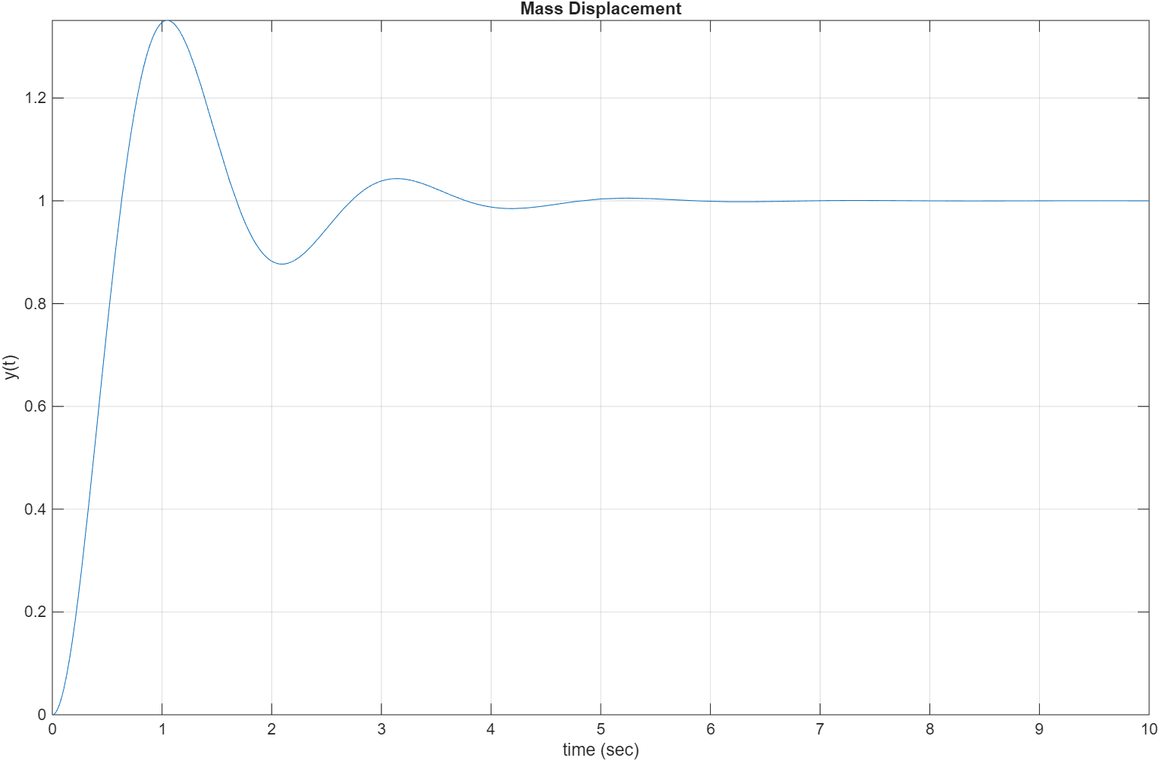

- Answer the following questions based on the graph.
a) What is the final steady-state value of the mass displacement? Is it same as the cart displacement?

The final steady state value of mass displacement is 1m, it is the same as the cart displacement.

b) Determine the maximum displacement of the mass from the steady-state value?

The maximum displacement of mass from steady state value would be 1.1 but reaching a maximum 1.3 in the miliseconds

c) Roughly determine the settling time, which is the time it takes for the mass to stop at the final position.

6 to 8 seconds to fully stop. With Friction and Air probably after 11 seconds

A.2. EFFECT OF THE DAMPING ELEMENT
- Modify the MATLAB code by changing the damping coefficient value first to $b\text{=}5 N.s\text{/}m$ and then to $b\text{=}80 N.s\text{/}m$. Run the code and find the solution for each case.
Provide the results:
Solution for $b\text{=}5 N.s\text{/}m$

sol1 = 1 - (159^(1/2)*exp(-t/4)*sin((159^(1/2)*t)/4))/159 - exp(-t/4)*cos((159^(1/2)*t)/4)

Solution for $b\text{=}80 N.s\text{/}m$

sol1 = exp(-t*(6^(1/2) + 4))*(6^(1/2)/3 - 1/2) - (6^(1/2)*exp(t*(6^(1/2) - 4))*(6^(1/2) + 4))/12 + 1

- Plot the response graphs for each case. Adjust the time range to capture and appropriate response.
Provide the graphs:

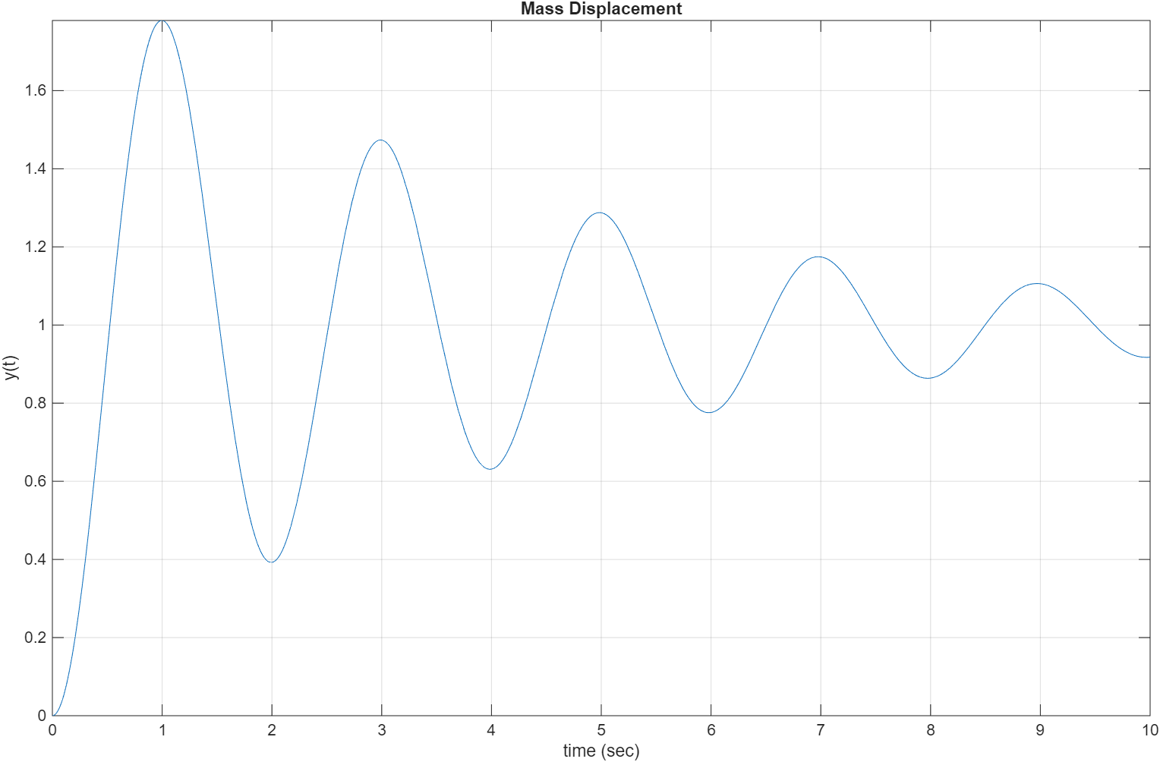

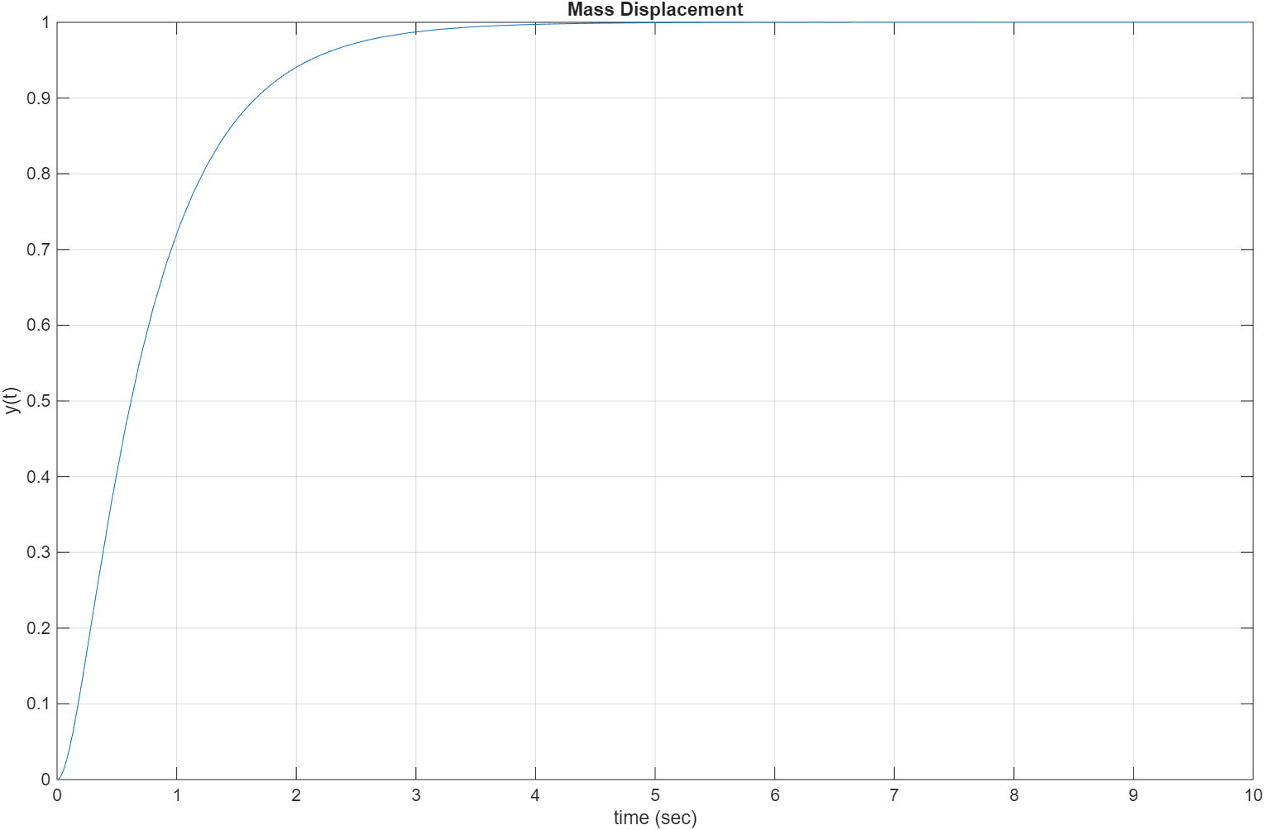

- Explain how changing the damping coefficient affects the transient response, oscillation and the settling time. Which system is underdamped, and which one is an over-damped system?

Changing the damping coefficient affects the transient response, oscillation, and settling time of the mass-spring-damper system. With a lower damping value, the system exhibits oscillations, overshoot, and a longer settling time, making it underdamped. In our case, (b=5) produces an underdamped system.
With a higher damping value, the system no longer oscillates and instead returns to steady-state more smoothly. This is characteristic of an overdamped response. For our system, (b=80) results in an overdamped system with no oscillations and a quicker settling time compared to the underdamped case.

A.3. EFFECT OF THE APPLIED INPUT
- Assume that the displacement of the cart (input) changes proportional to the time, $u\left(t\right)\text{=}t$. The input is called ramp input.
Rewrite the dynamic model of the system having the numerical values $m\text{=}10 kg$, $b\text{=}20 Ns\text{/}m$, and $k\text{=}100 N\text{/}m$ and the new input $u\left(t\right)\text{=}t$.
$m\overset{¨}{y}\left(t\right)\text{+}b\overset{˙}{y}\left(t\right)\text{+}ky\left(t\right)\text{=}b\overset{˙}{u}\left(t\right)\text{+}ku(t)$
10ÿ(t) + 20ẏ(t) + 100y(t) = 20(1) + 100(t)
Simplified: 10ÿ(t) + 20ẏ(t) + 100y(t) = 100(t) + 20

- Modify your MATLAB code to plot the new input, $u\left(t\right)\text{=}t$ and the response of the system to the new input.
Provide your code:
m = 10; % mass (kg)
b = 20; % viscous friction coefficient
k = 100; % spring constant (N/m)

syms t y(t); % Define symbolic variables and symbolic function

%---Definition of successive derivatives of y(t)---%
D1y = diff(y,1);
D2y = diff(y,2);

% Defined ramp Input %
u = t;
Du = diff(u,t);

% Defined the dynamic model
eqn1 = m*D2y + b*D1y + k*y == b*Du + k*u;

sol1 = dsolve(eqn1, y(0)==0, D1y(0)==0) % Response of the model

% Plot the solution y(t) as a function of t
figure;
fplot(sol1, [0,10]), grid on
xlabel('time (sec)'), ylabel('y(t)'), title('Mass Displacement (Ramp Imput)')
Run the code and provide the solution of the equation and the graph.
Solution of the model:

Sol1 = t - (sin(3*t)*exp(-t))/3

Graph of the mass displacement and input:

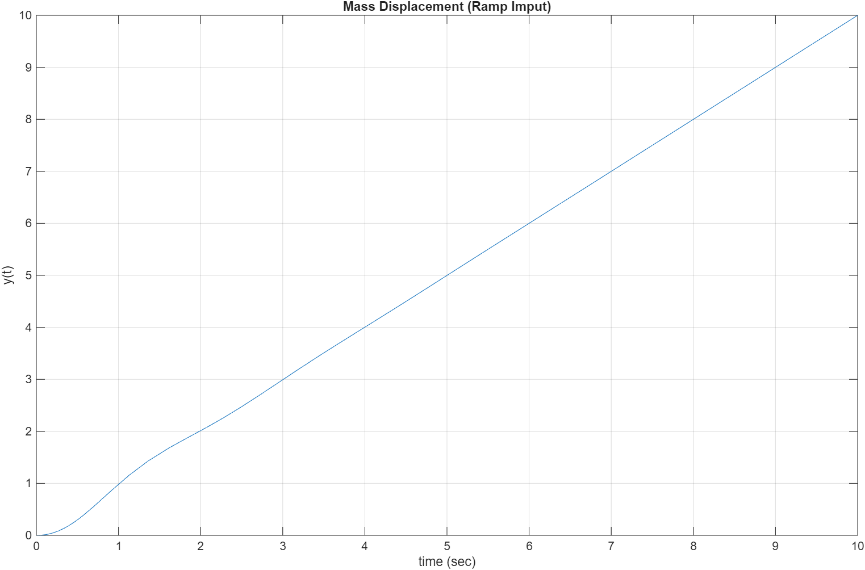

PART B: Developing Linear Models from Data
A linear model of a static system element has the form $y \text{=} mx$, where $x$ is the input and $y$ is the output of the element. As we know that solution of dynamic models to predict system performance requires solution of differential equations. Differential equations based on linear models of the system elements are easier to solve than ones based on nonlinear models. Therefore, when developing models, we try to obtain a linear model whenever possible.
Sometimes the use of a linear model results in a loss of accuracy, and the engineer must weigh this disadvantage with advantages gained by using a linear model. In this part, we illustrate a way to obtain linear model and check the quality of the linear model estimation.
If we are given data on the input-output characteristics of a system element, we can first plot the data to see whether a linear model is appropriate, and if so, we can extract a suitable model.
This part illustrates a common engineering problem: the estimation of the force-deflection characteristics of a cantilever support beam.
The deflection of a cantilever beam is the distance its end moves in response to a force applied at the end as shown in Figure 2.
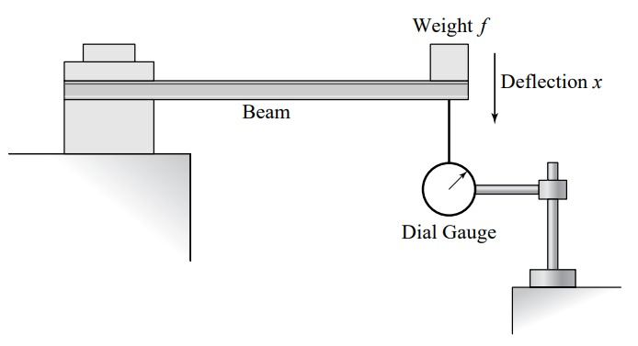
Figure 2: Measurement of beam deflection

The following table gives the measured beam deflection $x$ that was produced in a particular beam by the given applied force $f$.

Force $f$ ($N$) | 0 | 100 | 200 | 300 | 400 | 500 | 600 | 700 | 800
Deflection $x$ ($cm$) | 0 | 0.15 | 0.23 | 0.35 | 0.37 | 0.5 | 0.57 | 0.68 | 0.77

The goal is to estimate the stiffness $k$ of the beam from the linear model and evaluate the quality of the estimation based on the least-squares criterion; sum of the squares of the residuals $J$.
$$f\text{=}kx$$
$$J\text{=}\sum_{i\text{=}1}^{n}{{\left|\frac{f_{i}}{k}\text{-}x_{i}\right|}^{2}}$$
- Open a new script file and save it as Lab1_PartB. Insert and run the following code in MATLAB to plot the data to see whether a linear relation exists between $f$ and $x$.
% Enter the input-output data
x = [0 0.15 0.23 0.35 0.37 0.5 0.57 0.68 0.77]; % Beam deflection (cm)
f = [0 100 200 300 400 500 600 700 800]; % Applied force (N)

% Plot the data
figure;
plot(f,x,'o')
xlabel('Applied Force (N)'), ylabel('Beam deflection (cm)')
title('Beam deflection vs Applied force')

Provide the graph here:

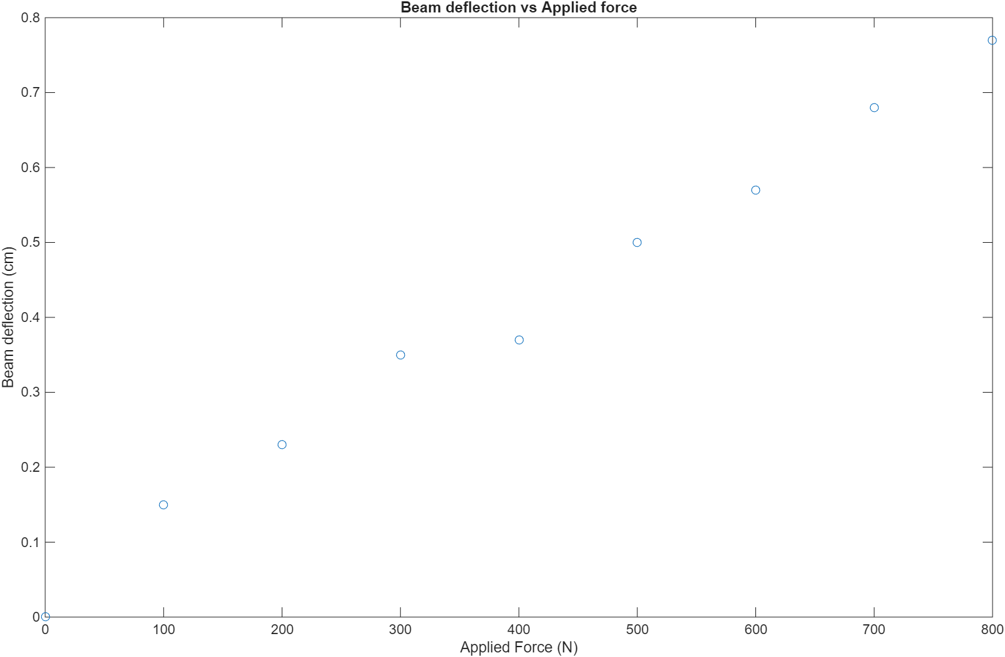

- Since there must be zero beam deflection if there is no applied force, so the curve describing the data must pass through the origin.
Therefore, we can use the linear function $x\text{=}mf$ to describe the relation. The value $m$ can be determined from the slope of the line.
The stiffness of the beam is obtained as:
$$k\text{=}\frac{1}{m}$$
Run the following code in MATLAB to compute the slope of the line and find the stiffness $k$ of the beam.

% Compute the slope
m = sum(f.*x)/sum(f.^2);

% Compute the stiffness k
k = 1/m

Provide the results in the following table:
Slope of the line | Stiffness $k$ ($N\text{/}cm$) | Stiffness $k$ ($N\text{/}m$)
M = 9.7941e-04 | K = 1.0210e+03 | K = 1.0210e+05

Run the following code in MATLAB to plot the linear model and the data:
% Compute the linear model from f=kx
xl = f./k;

% Plot the linear model and the data
figure;
plot(f,xl,f,x,'o')
xlabel('Applied Force (N)'), ylabel('Beam deflection (cm)')
title('Linear Model & Data')

Provide the graph here:

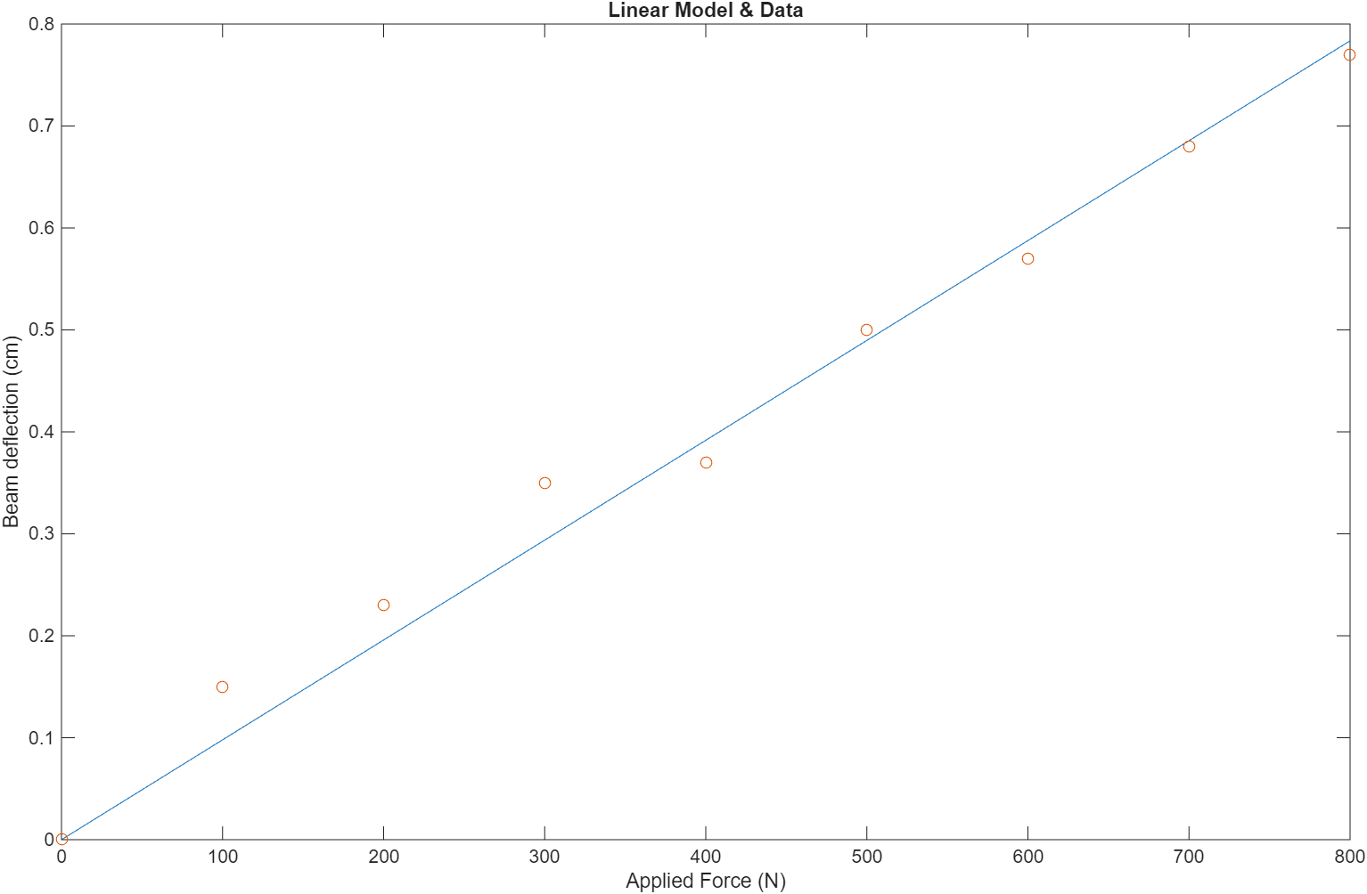

- To check the quality of the linear model estimation we can calculate the least-squares criterion, which is the sum of the squares of the residuals.
The residuals represent the error between the data value $x_{i}$ and the value of $x$ obtained from the linear model; that is $mf_{i}$.
$$J\text{=}\sum_{i\text{=}1}^{n}{{\text{|}mf_{i}\text{-}x_{i}\text{|}}^{2}}$$

Run the following code in MATLAB to calculate the least-squares criterion:
% Compute the sum of the squares of the residuals
J = sum((m*f-x).^2)

Provide the result and explain if the quality of the linear model estimation is good enough:
J = 8.1353e-03
The small deviations likely come from measurement noise, experimental imperfections, or slight nonlinearity in the beam, but they don’t significantly reduce model accuracy.

- Use the linear model to estimate the beam deflection when the applied force is $550 N$. Estimate how much force is required to bend the beam $0.6 cm$. Show our work.
M = 2328/2342500 k = 1/0.000994 x = 550/k
m = 0.000994 k = 1006 N/cm x ≈ 0.547

f=1006*0.6
f ≈ 603.6 N

The required force would be close to 604 N

- Explain can we use the linear model to predict the required force to bend the beam $1.5 cm$. Why? Justify your answer.
We can predict the required force to bend the beam 1.5 cm, but in our data set it is double what our measured data, so the linear approximation may not be valid. Linear models are valid only within the data range where the relationship is approximately proportional. Beyond that range, extrapolation is unsafe.

Post Lab Assignment
- Consider the following differential equation represented a dynamic system with input of $f(t)$ and output of $x(t)$:
$$\overset{¨}{x}\left(t\right)\text{+}3\overset{˙}{x}\left(t\right)\text{+}5x\left(t\right)\text{=}10f\left(t\right), x\left(0\right)\text{=}0, \overset{˙}{x}\left(0\right)\text{=}0$$
- Create the differential equation model using the symbolic math in MATLAB for step input $f\left(t\right)\text{=}2$. Provide your code and results.
% --- Post Lab --- %
m = 1; % mass (kg)
b = 3; % viscous friction coefficient %(changed 5 and 80)%
k = 5; % spring constant (N/m)

syms t x(t); % Define symbolic variables and symbolic function

%---Definition of successive derivatives---%
D1x = diff(x,1);
D2x = diff(x,2);

% Defined Input %
f = 2;

% Defined the dynamic model
eqn = m*D2x + b*D1x + k*x == 10*f;

sol = dsolve(eqn, x(0)==0, D1x(0)==0) % Response of the model

Sol = 4 - (12*11^(1/2)*exp(-(3*t)/2)*sin((11^(1/2)*t)/2))/11 - 4*exp(-(3*t)/2)*cos((11^(1/2)*t)/2)
- Solve and plot the time response of the system for $f\left(t\right)\text{=}2$, over the time interval $0≤t≤10$. Provide your code, results and the graph.
% Plot the solution
figure;
fplot(sol, [0,10]), grid on
xlabel('time (sec)'), ylabel('x(t)'), title('System Response')
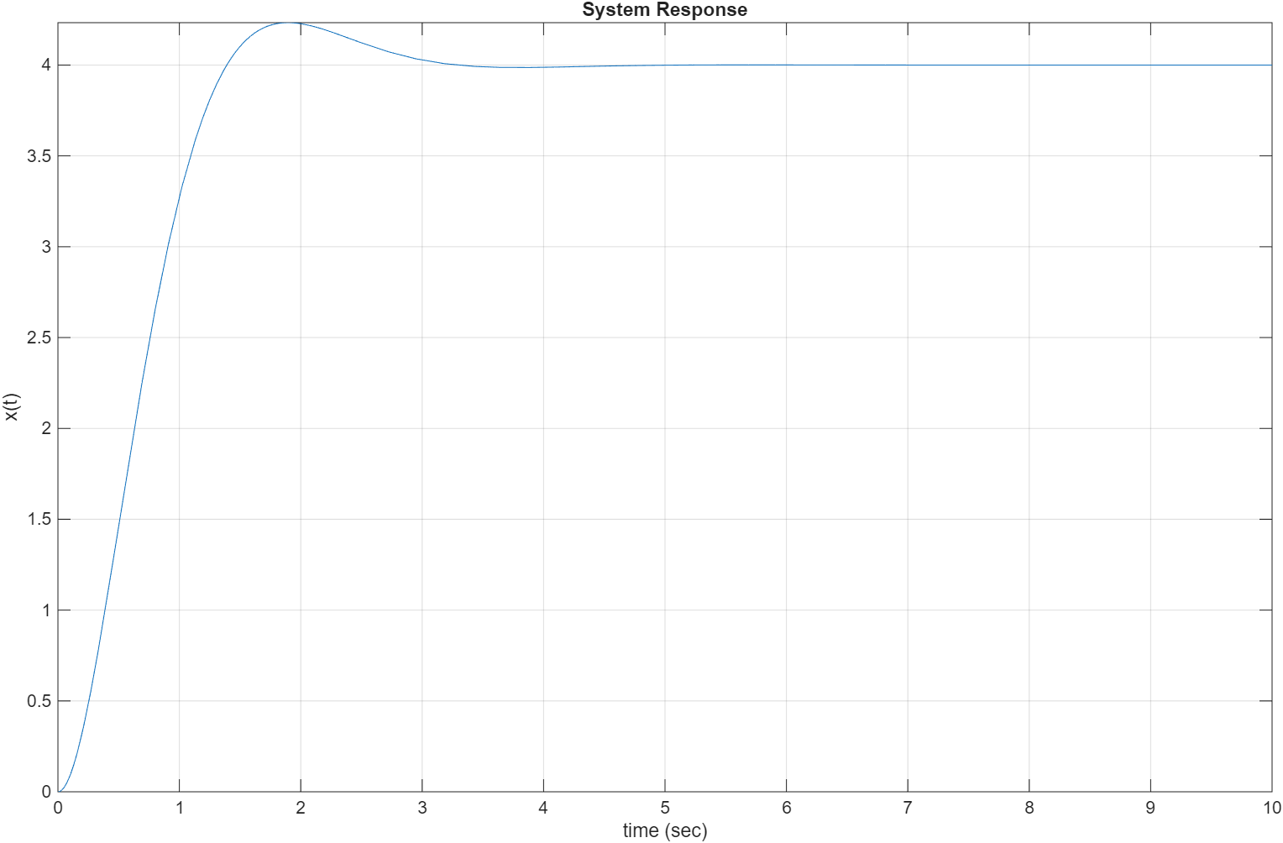
- Find the steady-state value and roughly estimate the settling time of the response from the graph.
The Steady state value is 4, and the settling time is around 3 to 5 seconds.
- Solve and plot the time response of the system for $f\left(t\right)\text{=}1.5t$, over the time interval $0≤t≤10$. Provide your code, results and the graph.
% --- Post Lab --- %
m = 1; % mass (kg)
b = 3; % viscous friction coefficient %(changed 5 and 80)%
k = 5; % spring constant (N/m)

syms t x(t); % Define symbolic variables and symbolic function

%---Definition of successive derivatives---%
D1x = diff(x,1);
D2x = diff(x,2);

% Defined Input %
f = 1.5*t;

% Defined the dynamic model
eqn = m*D2x + b*D1x + k*x == 10*f;

sol = dsolve(eqn, x(0)==0, D1x(0)==0) % Response of the model

% Plot the solution
figure;
fplot(sol, [0,10]), grid on
xlabel('time (sec)'), ylabel('x(t)'), title('System Response')

sol = 3*t + (9*exp(-(3*t)/2)*cos((11^(1/2)*t)/2))/5 - (3*11^(1/2)*exp(-(3*t)/2)*sin((11^(1/2)*t)/2))/55 – 9/5

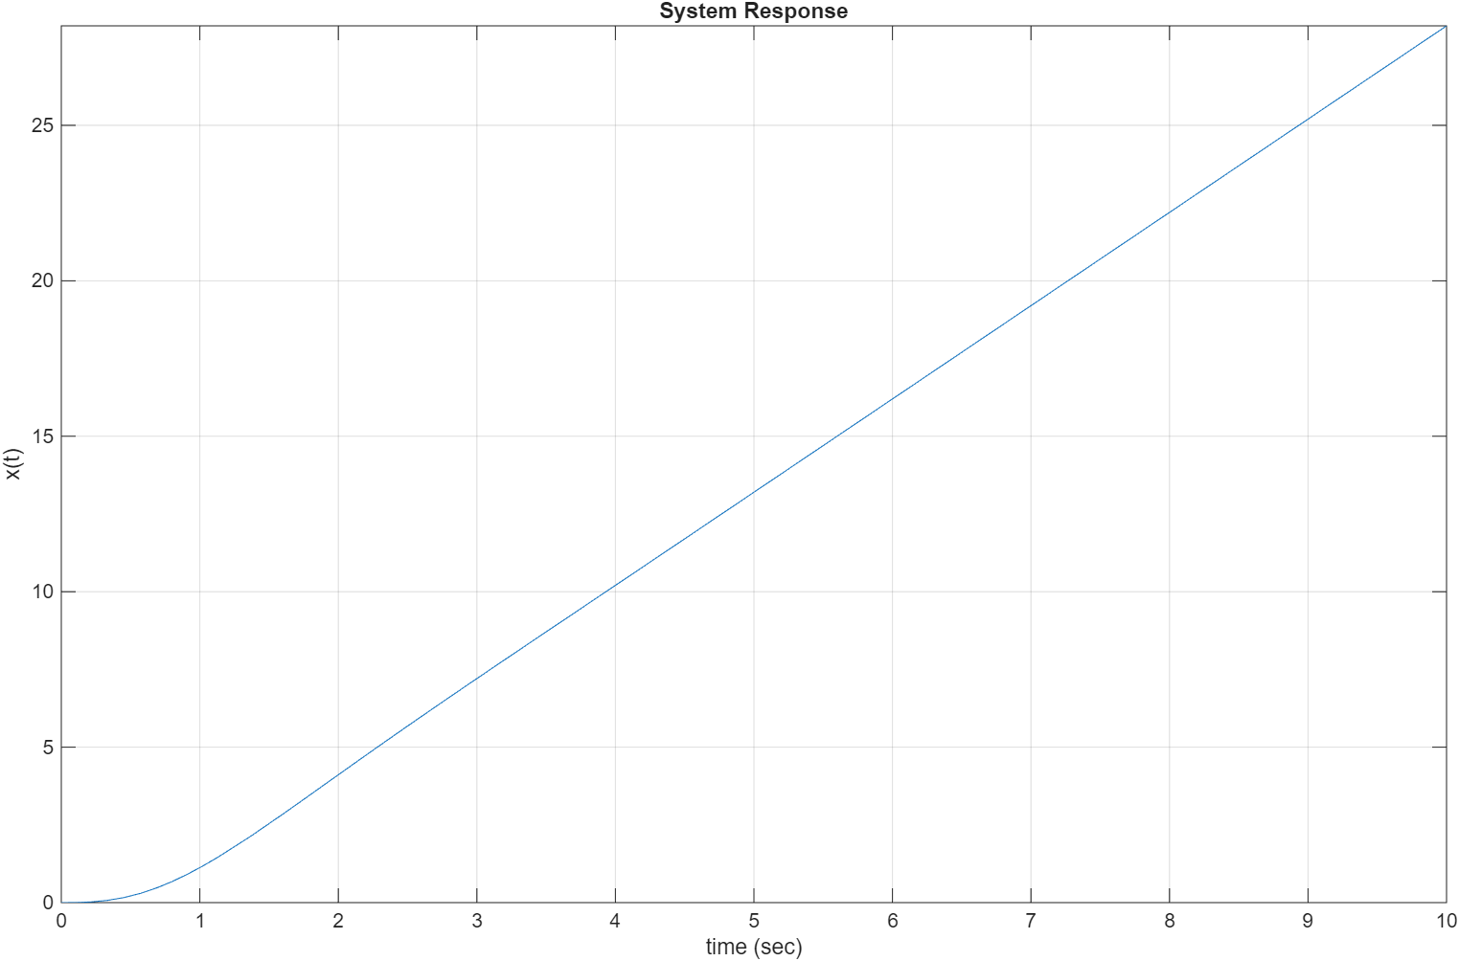
2) Estimate a linear model $y\text{=}mx$ to the given data in the following table. Evaluate the quality of the estimation by computing the least-squares criterion.
$$x$$ | 0 | 2 | 4 | 6
$$y$$ | 4.5 | 39 | 72 | 94
% --- Post Lab 2 --- %
% Enter the input-output data
x = [0 2 4 6];
y = [4.5 39 72 94];
% Compute the slope
m = sum(x.*y)/sum(y.^2);
% Compute the stiffness k
k = 1/m;
% Compute the linear model from f=kx
x1 = y./k;
% Plot the linear model and the data
figure;
plot(y,x1,y,x,'o')
title('Linear Model & Data')
% Compute the sum of the squares of the residuals
J = sum((m*y-x).^2)
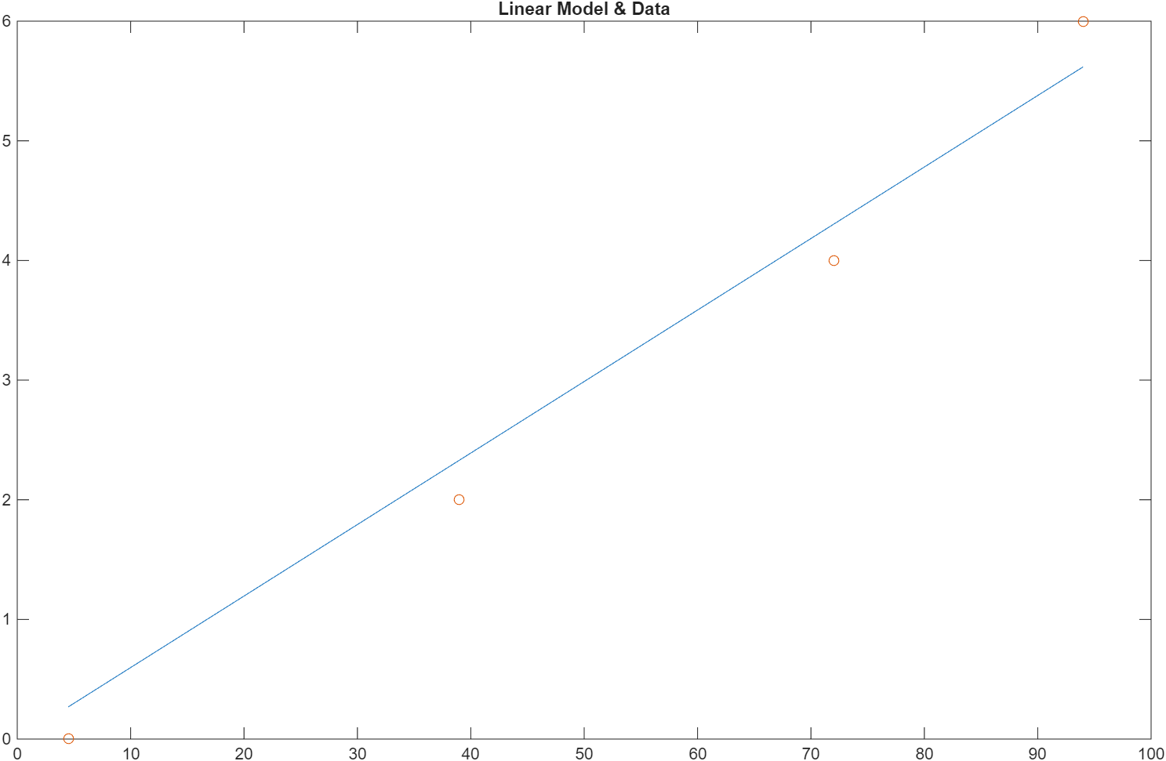

J = 0.41963
the quality of the estimation by computing the least-squares criterion is good, as the error is small relative to the magnitude of x & y.

